|  |
| --- |
|  |
| Assignment 1-CompuTech Solutions  Web Project |
| |  |  |  | | --- | --- | --- | | Clinton Rodrigues, Darryl Fernandes, Trevor Machado | 2/16/13 | CIS 285 | |

Table of Contents

Introduction: 1

Home: 2

Android: 3

How to Go About (Navigation): 4

Top 5 Android Apps: 4

iOS: 6

How to Go About (Navigation): 7

Top 5 iOS Apps: 7

Windows: 8

How to Go About (Navigation): 8

Top 5 Windows Apps: 9

Blackberry: 11

How to Go About (Navigation): 11

Top 5 Blackberry Apps: 12

## Introduction:

CompuTech Solutions, is a small group of tech-savvy specialist who have brought together a website containing the most favorite rated apps for 4 of the most popular mobile platforms.

The website ‘CompuTech Solutions’, provides users with insight to many popular platforms like:

* Android
* iOS
* Windows
* Blackberry

These four platforms are the most widely used mobile platform across the globe.

According to popular ranking and a brief survey, Android ranks #1 on the top list as many of the user in the world would buy a smartphone that supports Android because of its cheaper variants of phones and tons of applications.

Apple’s iPhone ranks #2 on the chart, as it is a smartphone which is more on the expensive side of the market. iPhone runs on its popular operating system called ‘iOS’. Being very secure, it is undoubtedly the fastest operating system in terms of usage beating Android by near inches.

Windows is another competitor in the market which is popular due to its predecessor in the computer operating system market. It offers great apps over its ‘Microsoft Store’, but fails in the long-running competition between Android and iOS.

One of the oldest smartphone makers, Blackberry still runs in the market with new development to their operating system and few of their phones now supporting Android applications. They had a huge market prior to the introduction of Android’s and iPhones’. They were better known for their popular social-messaging application ‘Blackberry Messenger a.k.a. BBM’.

## Home:

The ‘Home’ page, is the first page and the introduction page to ‘CompuTech Solutions’. It is a detailed webpage that delivers information regarding the content available on the website.

The ‘Home’ page is mainly divided into 4 sections:

* Top 5 Android Apps
* Top 5 iOS Apps
* Top 5 Windows Apps
* Top 5 Blackberry Apps

Each section provides brief information regarding each platform and the top 5 apps associated with it.

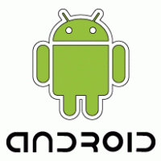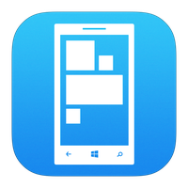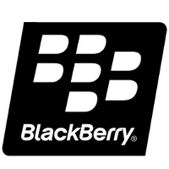

Above are the brand labels for four of the most popular mobile platforms.

Each sections provides navigation links which takes the users to the top 5 apps for their respective platform.

Every link in either Android, iOS, Windows or Blackberry, contain 5 apps with brief description along with its ‘Download’ and ‘Frequently Asked Question’ link.

## Android:

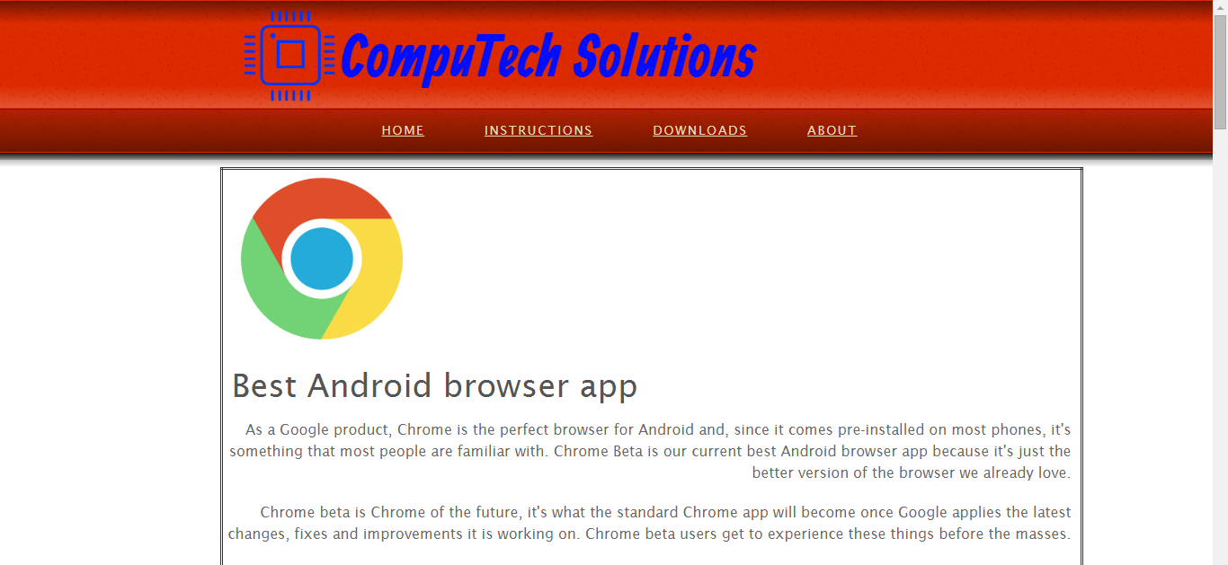

Android is the name of the mobile operating system made by American company; Google. It most commonly comes installed on a variety of smartphones and tablets from a host of manufacturers offering users access to Google's own services like Search, YouTube, Maps, Gmail and more.

Android phones are highly customisable and as such can be altered to suit your tastes and needs; with wallpapers, themes and launchers which completely change the look of your devices interface. You can download applications to do all sorts of things like check your Facebook and Twitter feeds, manage your bank account, order pizza and play games. You can plan events on from your phone's calendar and see them on your computer or browse websites on your desktop and pick them up on your phone.

### How to Go About (Navigation):

If you click on the “**Read More”** link the website will direct, you to a new page which gives you a brief introduction on the ‘Top 5 Android Apps’. This page also includes the ‘Download Links’ which gives a direct access to the website through which the apps can be downloaded whereas the ‘Frequently asked questions links’ gives you the direct access to the websites which gives you the answers to the generally asked customer user queries.

### Top 5 Android Apps:

1. **Best Android Browser App (Google Chrome):**

As a Google product, Chrome is the perfect browser for Android and, since it comes pre-installed on most phones, it’s something that most people are familiar with. Chrome Beta is our current best Android browser app because it’s just the, ahem, better version of the browser we already love.

Chrome beta is Chrome of the future, it’s what the standard Chrome app will become once Google applies the latest changes, fixes and improvements it is working on. Chrome beta users get to experience these things before the masses.

The price paid for quicker access to new features is that, of course, sometimes there are bugs or issues that need to be ironed out. None of these will cause any damage to your phone or its software however, and these browser crashes and stutters very rare.

**DOWNLOAD LINK:** [**https://play.google.com/store/apps/details?id=com.chrome.beta&hl=en**](https://play.google.com/store/apps/details?id=com.chrome.beta&hl=en)

**FREQUENTLY ASKED QUESTIONS:**

[**https://support.google.com/chrome/?hl=en#topic=3227046**](https://support.google.com/chrome/?hl=en#topic=3227046)

1. **Best Security/Antivirus App (Avast Antivirus):**

Android security is a contentious subject and arguments about the safety of the system crop up frequently. If you are in the market for an antivirus app, our current favorite is Mobile Security & Antivirus from Avast.

Mobile Security & Antivirus keeps you safe from malware threats with its excellent virus detection software, which can search through your browser history, micro SD card, and internal storage space. What's more, it employs anti-theft features such as location tracking and remote data wipe, which work even if your device is not currently in your possession.

As far as free mobile security is concerned, Avast's app is about as comprehensive as it gets.

**DOWNLOAD LINK:** [**https://play.google.com/store/apps/details?id=com.avast.android.mobilesecurity&hl=en**](https://play.google.com/store/apps/details?id=com.avast.android.mobilesecurity&hl=en)

**FREQUENTLY ASKED QUESTIONS:**

[**https://www.avast.com/faq.php**](https://www.avast.com/faq.php)

1. **Best Android Keyboard App (Flesky Keyboard):**

This keyboard is one of the best for fast, accurate typing and it’s our new company favorite. Many of us have adopted Fleksy because it’s big, it’s clever and once you use it for a couple of hours, you realize how useful some of the smaller details are.

For example, most keyboards use a "press and hold delete key" gesture to delete words, Fleksy uses a super-quick backward swipe. Be sure check out some of the extensions like invisible keyboard too — it works surprisingly well. Download it from the Play Store for free now.

**DOWNLOAD LINK:** [**https://play.google.com/store/apps/details?id=com.syntellia.fleksy.keyboard&hl=en**](https://play.google.com/store/apps/details?id=com.syntellia.fleksy.keyboard&hl=en)

**FREQUENTLY ASKED QUESTIONS:**

[**http://feedback.fleksy.com/knowledgebase**](http://feedback.fleksy.com/knowledgebase)

1. **Best app for downloading free music on Android (Google Music):**

Google Play Music is our favorite app for downloading free music right now. Though there are many music download apps available in the Play Store, they are often quickly removed because of their copyright-impinging functionality. Google Play Music provides you with a totally legit, ever-changing list of free tracks from major artists to download.

Spotify has an excellent paid subscription service, and Sound Cloud has a multitude of tracks readily available to stream, but for actually downloading tracks to your phone, Google Play Music is as good as you can get.

Alternatively, head to the link below for some less common free music downloading apps.

**DOWNLOAD LINK:** [**https://play.google.com/store/apps/details?id=com.google.android.music&hl=en**](https://play.google.com/store/apps/details?id=com.google.android.music&hl=en)

**FREQUENTLY ASKED QUESTIONS:**

[**https://support.google.com/googleplay/answer/4515411?hl=en**](https://support.google.com/googleplay/answer/4515411?hl=en)

1. **Best image-editing app for Android (Photo Director):**

Photo Director is the whole package. It has everything you could possibly need to edit your photos. The tools range from simple text bubbles and filters, to more complex things such as HSL and curves, and they're all heavily adjustable, helping you get the best out of your photos. It's for messing around on and seeing what you end up with.

The app is developed by Cyber Link, a large Taiwanese multimedia software company, so they have the money to splash on an app, and it shows. Highly recommended for novices and pros-on-the-go alike.

**DOWNLOAD LINK:** [**https://play.google.com/store/apps/details?id=com.cyberlink.photodirector&hl=en**](https://play.google.com/store/apps/details?id=com.cyberlink.photodirector&hl=en)

**FREQUENTLY ASKED QUESTIONS:**

[**https://www.cyberlink.com/support/photodirector-ultra/userguide_en_US.html**](https://www.cyberlink.com/support/photodirector-ultra/userguide_en_US.html)

## iOS:

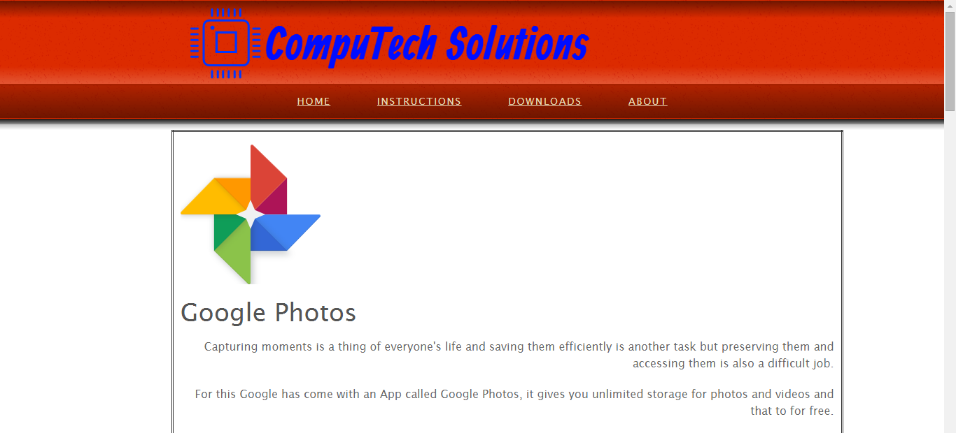

Designed for use with Apple’s multi-touch devices, iOS supports input through direct manipulation. The system responds to various user gestures, such as pinching, tapping and swiping

Features of iOS are as follows:

* Integrated search support enables simulations search through files, media, applications and email.
* Gesture recognition supports for example, shaking the device to undo the most recent action.
* Google maps direction services.
* Push email.

### How to Go About (Navigation):

If you click on the “**Read More”** link the website will direct, you to a new page which gives you a brief introduction on the ‘Top 5 iOS Apps’. This page also includes the ‘Download Links’ which gives a direct access to the website through which the apps can be downloaded whereas the ‘Frequently asked questions links’ gives you the direct access to the websites which gives you the answers to the generally asked customer user queries.

### Top 5 iOS Apps:

1. **Google Photos:**

Capturing moments is a thing of everyone’s life and saving them efficiently is another task but preserving them and accessing them is also a difficult job. For this Google has come with an App called Google Photos, it gives you unlimited storage for photos and videos and that to for free. Although it is an iOS App it also works on computers and Android devices

**DOWNLOAD LINK:** [**https://photos.google.com/apps**](https://photos.google.com/apps)

**FREQUENTLY ASKED QUESTIONS:** [**https://support.google.com/photos/answer/6220791?hl=en**](https://support.google.com/photos/answer/6220791?hl=en)

1. **Uber:**

As we all know how hard it is to get a cab. The Uber app is transforming the way we travel. It allows you to set a pickup of a taxi from you App it also has a feature of setting a pickup location and you’ll get picked up within minutes. The App also helps you with comparing the rates with other cab companies. The payment method is also quite efficient as it allows you to pay online with Uber’s secure account either through PayPal or through other credit cards.

**DOWNLOAD LINK:** [**https://play.google.com/store/apps/details?id=com.ubercab&hl=en**](https://play.google.com/store/apps/details?id=com.ubercab&hl=en)

**FREQUENTLY ASKED QUESTIONS:**  [**https://drive.uber.com/oh/faqs/**](https://drive.uber.com/oh/faqs/)

1. **Evernote Scannable:**

The Evernote scan able helps you to scan documents on a go by just scanning the document on a background with enough contrast, and boom it scans the document in just a moment. The scanned document can further be shared to Evernote, or to any other devices or save to a PDF format.

**DOWNLOAD LINK:** [**http://evernote-scannable.en.softonic.com/iphone/download**](http://evernote-scannable.en.softonic.com/iphone/download)

**FREQUENTLY ASKED QUESTIONS:** [**https://discussion.evernote.com/forum/207-scannable-help/**](https://discussion.evernote.com/forum/207-scannable-help/)

1. **Pushbullet:**

This App helps you to view your iPhone’s notifications and messages directly on your computer. If you are busy working on you PC and your phone is somewhere else you don’t have to miss out on any of your important calls or messages with PUSHBULLET App. This App also helps to quickly send files from your computer to your phone only with a few clicks.

**DOWNLOAD LINK:** [**https://play.google.com/store/apps/details?id=com.pushbullet.android&hl=en**](https://play.google.com/store/apps/details?id=com.pushbullet.android&hl=en)

**FREQUENTLY ASKED QUESTIONS:** [**https://help.pushbullet.com/**](https://help.pushbullet.com/)

1. **Dropbox:**

Plenty of apps exist for transferring content between your computer and your device, but [Dropbox](http://itunes.apple.com/gb/app/dropbox/id327630330?mt=8%20) is free and easier to use. It also helps you to sync with your computer or mobile device. Dropbox helps you to access your files, images, doc etc. from anywhere.

**DOWNLOAD LINK:** [**https://play.google.com/store/apps/details?id=com.dropbox.ios&hl=en**](https://play.google.com/store/apps/details?id=com.dropbox.ios&hl=en)

**FREQUENTLY ASKED QUESTIONS:** [**https://www.dropbox.com/help**](https://www.dropbox.com/help)

## Windows:

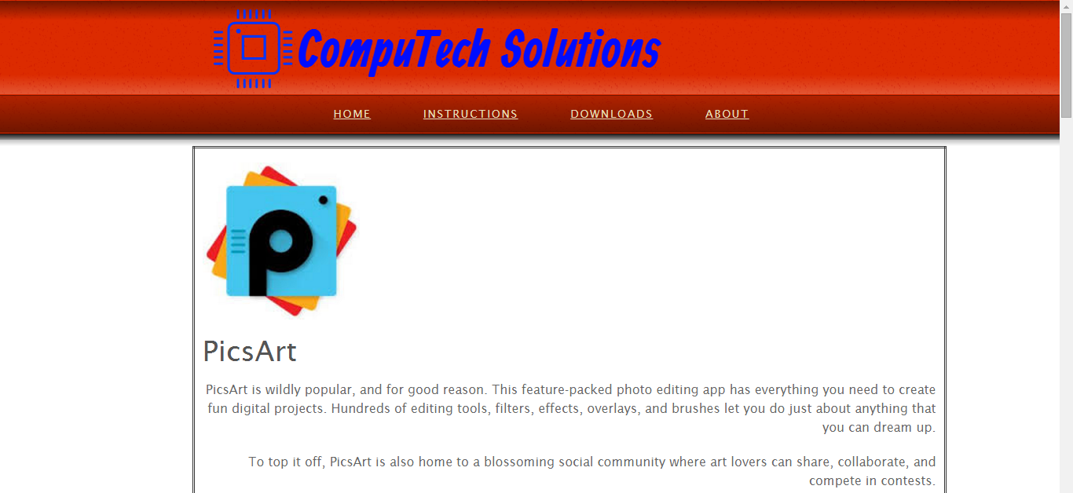

Windows OS, computer operating system developed by Microsoft Corporation to run personal computers (PCs). Featuring the first graphical user interface (GUI) for IBM-compatible PCs, the Windows OS soon dominated the PC market.

However, Windows also is taking over the telecommunication sector by launching various Windows Cellular phones. It gives the user to select between Android and Windows with a vast variety of apps supported by both of them

### How to Go About (Navigation):

If you click on the “**Read More”** link the website will direct, you to a new page which gives you a brief introduction on the ‘Top 5 Windows Apps’. This page also includes the ‘Download Links’ which gives a direct access to the website through which the apps can be downloaded whereas the ‘Frequently asked questions links’ gives you the direct access to the websites which gives you the answers to the generally asked customer user queries.

### Top 5 Windows Apps:

1. **Spotify:**

Spotify is the only music APP that gives you access to music from all round the world. It also has every music record you can ever think of. The app allows you to create your own playlist and list to music on the go. Moreover, it has many cool features to look out for. Spotify being free is becoming a cool trend on the go.

**DOWNLOAD LINK:** [**https://www.spotify.com/ca-en/download/windows/**](https://www.spotify.com/ca-en/download/windows/)

**FREQUENTLY ASKED QUESTIONS:** <https://community.spotify.com/t5/Newcomers-and-Contribution/FAQ-Questions-and-Answers-about-Spotify/td-p/38501>

1. **VLC Player:**

VLC has a great reputation for being an all-in-one media player that will play just about anything you throw at it with minimal fuss and maximum configurability. VLC is also known to run most of the file types. Clarity offered by VLC is also good. VLC can be termed as an all in one player.

**DOWNLOAD LINK:** [**http://www.videolan.org/vlc/download-windows.html**](http://www.videolan.org/vlc/download-windows.html)

**FREQUENTLY ASKED QUESTIONS:** <http://www.videolan.org/support/faq.html>

1. **PicsArt:**

PicsArt is wildly popular, and for good reason. This feature-packed photo editing app has everything you need to create fun digital projects. Hundreds of editing tools, filters, effects, overlays, and brushes let you do just about anything that you can dream up.

To top it off, PicsArt is also home to a blossoming social community where art lovers can share, collaborate, and compete in contests.

Now you can save JPEG and BMP, and several new effects are available for your artistic pleasure

**DOWNLOAD LINK:** [**https://www.microsoft.com/en-ca/store/apps/picsart-photo-studio/9wzdncrfj10m**](https://www.microsoft.com/en-ca/store/apps/picsart-photo-studio/9wzdncrfj10m)

**FREQUENTLY ASKED QUESTIONS:** [**http://picsart.com/faq**](http://picsart.com/faq)

1. **Vine:**

If you prefer your entertainment to come in the form of six-second video loops, you'll be happy to hear that Vine has recently received a few new features in its latest update.

Now you can show love to your favorite Vine stars even quicker with the new double tap to like feature and find new Viner’s to follow using the Find People feature.

**DOWNLOAD LINK:** [**https://www.microsoft.com/en-ca/store/apps/vine/9wzdncrfj0zm**](https://www.microsoft.com/en-ca/store/apps/vine/9wzdncrfj0zm)

**FREQUENTLY ASKED QUESTIONS:** [**http://help.vine.co/**](http://help.vine.co/)

1. **6tag:**

6tag is the name of a popular third-party Instagram app for Windows Phone. It is developed by Rudy Huyn, and it is one of the most full-featured Instagram apps available, even offering unique features not found in the official Instagram apps on iOS, Android, or Windows Phone.

The 6tag app contains numerous features not found in official Instagram apps, including:

* Regram – Repost another person's Instagram image to your account
* Multiple Account Support – Users can manage and post from different accounts within the app
* Hide Sponsored Posts – Lets users hide ads in their photo stream
* Photo features – Ability to use a border and upload full images with top and bottom margins for non-cropped photos

**DOWNLOAD LINK:** [**https://www.microsoft.com/en-us/store/apps/6tag/9wzdncrfhvxc**](https://www.microsoft.com/en-us/store/apps/6tag/9wzdncrfhvxc)

**FREQUENTLY ASKED QUESTIONS:** [**http://forums.windowscentral.com/ask/?utm_medium=navbar&utm_campaign=navigation&utm_source=wc**](http://forums.windowscentral.com/ask/?utm_medium=navbar&utm_campaign=navigation&utm_source=wc)

## Blackberry:

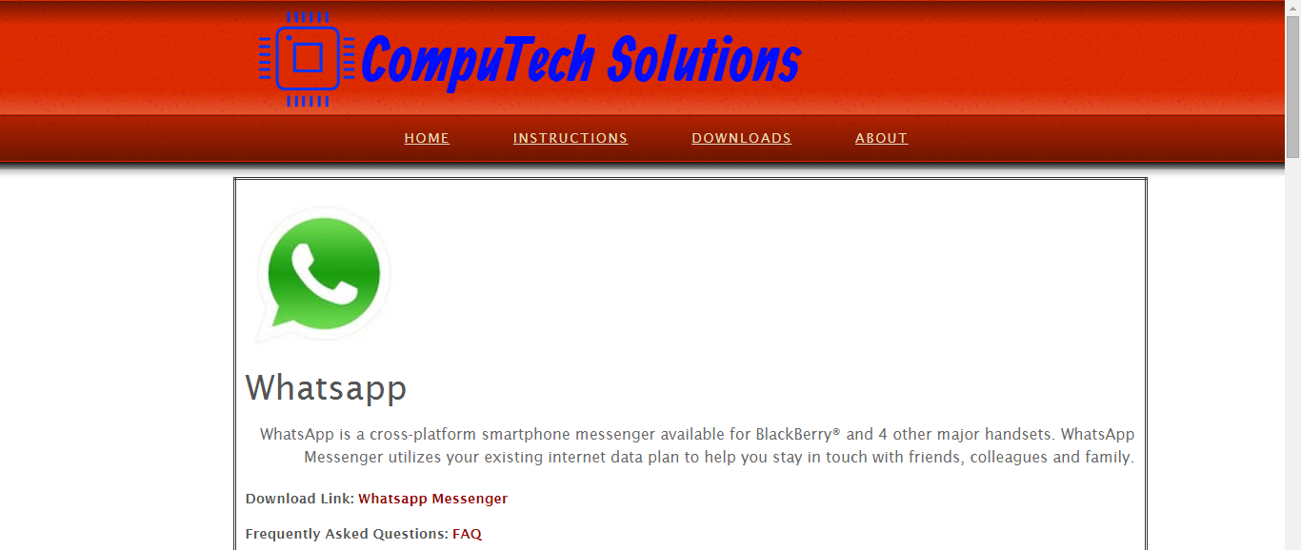

Blackberry is considered one of the major smartphone vendors in the world, specializing in secure communications and mobile productivity. For use on devices made prior to the new Blackberry 10 Operating System (BBOS 7 and earlier), the consumer BlackBerry Internet Service is available in 91 countries worldwide on over 500 mobile service operators using various mobile technologies. As of September 2013, there were 85 million BlackBerry subscribers worldwide. That number has dropped steadily, down to 46 million in September 2014. Starting in November 2013, BlackBerry Messenger could be run on multiple platforms including Android, iOS and Windows Phone, and up to June 2015 got 260 million new users.

In September 2015, Blackberry announced it would launch a new smartphone called Priv on the Android platform. The Priv is expected to work with many of the world's carriers, and the four major carriers in the US.

### How to Go About (Navigation):

If you click on the “**Read More”** link the website will direct, you to a new page which gives you a brief introduction on the ‘Top 5 Blackberry Apps’. This page also includes the ‘Download Links’ which gives a direct access to the website through which the apps can be downloaded whereas the ‘Frequently asked questions links’ gives you the direct access to the websites which gives you the answers to the generally asked customer user queries.

### Top 5 Blackberry Apps:

1. **Opera Mini web browser:**

Opera Mini's unique compression technology saves data and lets you browse up to 90% faster. With Opera Mini, you get a better connection even when you're off the map.

Get up to 90% faster internet for free. Opera Mini lets you share your phone with your friends and family without worry. Using Opera Mini's private browsing, your browsing habits and history remain a secret.

The newest Opera Mini browser introduces night mode, allowing you to dim your phone's screen while you browse. Stay up late and keep browsing without straining your eyes in the dark or attracting pesky insects.

**DOWNLOAD LINK:** [**https://appworld.blackberry.com/webstore/content/43001/?lang=en&countrycode=CA**](https://appworld.blackberry.com/webstore/content/43001/?lang=en&countrycode=CA)

**FREQUENTLY ASKED QUESTIONS:** [**http://www.opera.com/help/mini/other**](http://www.opera.com/help/mini/other)

1. **360 Panorama:**

While the built-in BlackBerry camera does have plenty of great functions that include HDR (10.1), multiple modes, scenes and aspect ratios, there are still some things it just can't do. One of those is taking panoramic photos.

For that we have an awesome app in 360 Panorama. With 360 Panorama there aren't very many features, but what you can do is take awesome panoramas. It's dead simple to use and you can save files or share them instantly right from the app.

**DOWNLOAD LINK:** [**https://appworld.blackberry.com/webstore/content/25014206/?countrycode=CA&lang=en**](https://appworld.blackberry.com/webstore/content/25014206/?countrycode=CA&lang=en)

**FREQUENTLY ASKED QUESTIONS:** [**http://occipital.com/help**](http://occipital.com/help)

1. **Whatsapp:**

Whatsapp is a cross-platform smartphone messenger available for BlackBerry® and 4 other major handsets. Whatsapp Messenger utilizes your existing internet data plan to help you stay in touch with friends, colleagues and family.

**DOWNLOAD LINK:** [**https://appworld.blackberry.com/webstore/content/2360/?lang=en&countrycode=CA**](https://appworld.blackberry.com/webstore/content/2360/?lang=en&countrycode=CA)

**FREQUENTLY ASKED QUESTIONS:** [**https://www.whatsapp.com/faq/**](https://www.whatsapp.com/faq/)

1. **Facebook:**

Facebook for BlackBerry® smartphones makes it even easier to connect with friends and share your news while you're on the go.

Discover all the great ways Facebook works with your BlackBerry smartphone to help you stay connected and on top of your social life.

**DOWNLOAD LINK:** [**https://appworld.blackberry.com/webstore/content/680/?countrycode=CA&lang=en**](https://appworld.blackberry.com/webstore/content/680/?countrycode=CA&lang=en)

**FREQUENTLY ASKED QUESTIONS:** [**https://www.facebook.com/help/**](https://www.facebook.com/help/)

1. **Truecaller-Number Search:**

Have a missed call? Want to know who it is before you call back?

Over 200 million people use Truecaller to identify missed calls, search for people to get in touch with and keep their current contact's information up-to-date.

**DOWNLOAD LINK:** [**https://appworld.blackberry.com/webstore/content/54147896/?lang=en&countrycode=CA**](https://appworld.blackberry.com/webstore/content/54147896/?lang=en&countrycode=CA)

**FREQUENTLY ASKED QUESTIONS:** [**https://www.truecaller.com/support**](https://www.truecaller.com/support)